Warm-Up: Railroad Consolidation

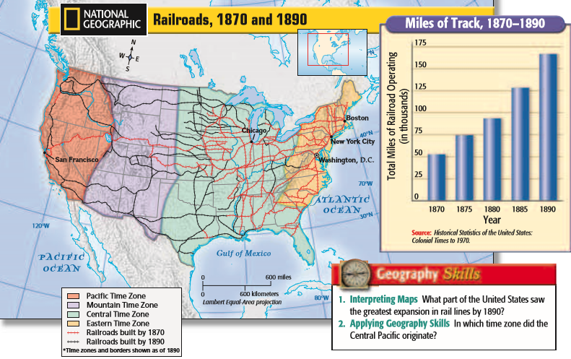

In the early 1800s, most railroads had been built to promote specific cities or to serve local needs. By 1865 hundreds of small unconnected lines existed.

The challenge for eastern capitalists was to create a single rail transportation system from this maze of small companies. Railroad consolidation proceeded rapidly from 1865 to 1900. Large rail lines took over about 400 small railroads, and by 1890 the Pennsylvania Railroad was a consolidation of 73 smaller companies. Eventually seven giant systems with terminals in major cities and scores of branches reaching into the countryside controlled most rail traffic.

One of the most famous and successful railroad consolidators was Cornelius Vanderbilt, a former boat captain who had built the largest steamboat fleet in America. By 1869 Vanderbilt had purchased and merged three short New York railroads to form the New York Central, running from New York City to Buffalo. Within four years he had extended his control over lines all the way to Chicago, which enabled him to offer the first direct rail service between New York City and Chicago.

- According to the chart, how much did railroad mileage increase in the United States from 1870 to 1890?

- How did railroad consolidation change the railroad industry?

- Who was Cornelius Vanderbilt?

- How did Vanderbilt impact the railroad industry?

